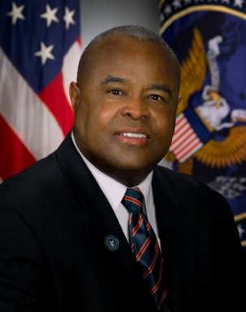
JOHN M. ROBINSON
Director of the Office of Civil Rights and Chief Diversity Officer
US Department of State
(202) 647-9295, johnmr1@state.gov

John M. Robinson was appointed Director of the Office of Civil Rights and Chief Diversity Officer for the Department of State in March, 2008. He serves as primary advisor to the Secretary of State and his senior leadership on EEO, diversity, affirmative employment, and related issues.

Prior to this appointment, Mr. Robinson was the first Chief of EEO and Diversity for the Office of the Director of National Intelligence. He served in a similar role for the Internal Revenue Service from 2001 to 2005.

Robinson was Senior Policy Advisor to the Secretary of the Department of Energy (DOE) from 1999 to 2001. There he was responsible for workplace and worklife improvements - i.e. employee relations, EEO reform, improving management practices, leadership development, labor relations, health and fitness, and community outreach. He helped DOE leaders recruit a more diverse workforce, achieve a healthier work style and create a more worker-friendly environment, all in partnership with DOE chapters of the National Treasury Employees Union. Mr. Robinson also led a Fact-Finding Delegation to DOE Nuclear Laboratories in the wake of the Wen Ho Lee Case; co-managed the DOE Task Force Against Racial Profiling; and was chief architect of the first DOE-Wide EEO/Diversity Stand Down.

Mr. Robinson completed a special assignment on the staff of the National Partnership for Reinventing Government, represented DOE on the White House Initiative on Asian American and Pacific Islanders and the EEO/NPR Government-Wide EEO Task Force. His federal service began in 1994 as Deputy Assistant Secretary in the Employment and Training Administration (ETA) of the U.S. Department of Labor (DOL). A consistent advocate for Total Quality Management and innovative management techniques, Mr. Robinson directed the U.S. Employment Service, was senior manager for ETA’s Reinvention Team and a charter member of both the agency’s Enterprise Council for Training Excellence and the Labor/Management Partnership Council. He was also ETA’s principal delegate for the Northern Ireland Growth Challenge for workforce development, lead Labor official for the Historically Black Colleges and Universities (HBCU) Initiative, DOL Lead Executive for both the DC Assistance Project and the St. Petersburg, Florida Interagency Task Force.

Prior to federal service, Mr. Robinson served in the Rhode Island Governor’s Cabinet as Director of the RI Department of Employment and Training from 1991 to 1993. He was a senior dean at Brown University before joining state government and held various administrative positions in higher education from 1973 to 1990. Selected in 1987 as a Group VIII Fellow of the Kellogg Foundation (Kellogg National Fellowship Program), Robinson studied leadership in the United States and abroad -- Belize, China, Brazil and Cuba. He completed training as a Baldridge Examiner. A Vietnam-era veteran, he served as a naval officer aboard a destroyer and an ammunition ship, and earned the Navy Commendation Medal. A graduate of Brown University, Mr. Robinson holds a Master’s degree from Tuskegee University and completed programs at the Center for Creative Leadership - Greensboro, the Federal Executive Institute - Charlottesville, and the Institute for Education Management at Harvard University. In 2007, Mr. Robinson completed the Senior Intelligence Fellows Program and in the same year received the Distinguished Alumnus Award from the Center for Creative Leadership.
October 25, 2016

